[](http://www.nativereflections.com/product_images/BST-01.jpg)

Was caught

Showing

[](http://www.nativereflections.com/extra_images/BST-01e-0.jpg)

Was caught

Showing

[](http://www.nativereflections.com/extra_images/BST-01e-1.jpg)

**Was caught**

**Showing**

[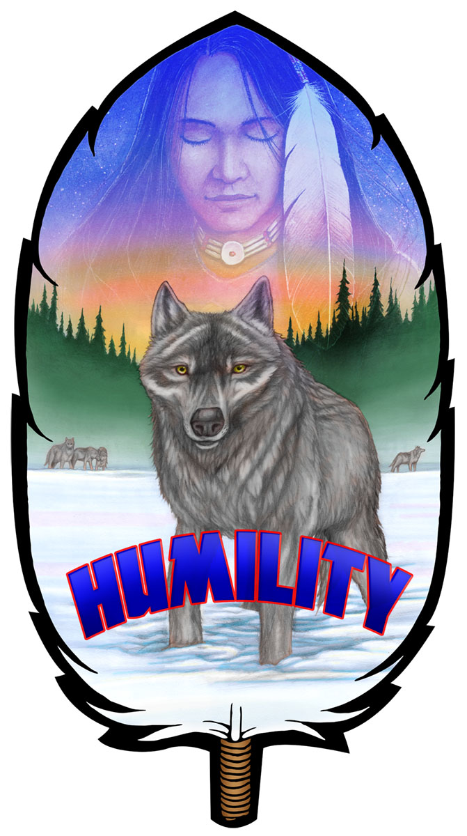](http://www.nativereflections.com/extra_images/BST-01e-2.jpg)

Was caught

Showing

[](http://www.nativereflections.com/extra_images/BST-01e-3.jpg)

Was caught

Showing

[](http://www.nativereflections.com/extra_images/BST-01e-4.jpg)

Was caught

Showing

[](http://www.nativereflections.com/extra_images/BST-01e-5.jpg)

Was caught

Showing